Gear teeth milling practice
What is it really ? A gear looks like this (hover cursor over pic to see site ad):

and we intend to cut the toothspaces from a cylindrical disk (which we call the blank) to get the gear. See the next fig and you will understand.

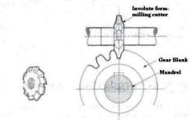

http://dc345.4shared.com/doc/4g4R82eU/preview.html
Hence it boils down to the question of dividing the circumference into n number of divisions and repeating the cutting action as shown above. And that is exactly what you have already done – do you recall having cut hexagons and squares in the first year ?
At that time – you had used a pc of equipment for dividing the circumference and it is called a dividing head or indexing head. There were six sides to be cut and you had used a ratio 40/Z to determine the number of turns that you had to apply to a crank handle on the dividing head.

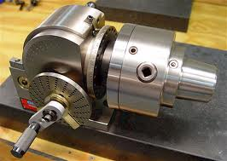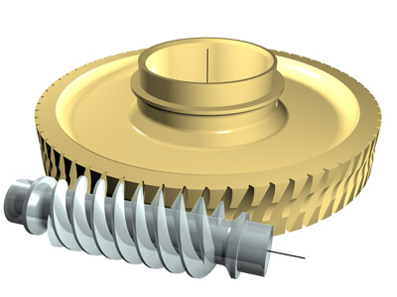
Dividing head - reference given later http://www.zakgear.com/Worm_Gear_software.html

40/Z comes this way – if you have a worm (single start) which meshes with a worm gear with 40 teeth,
One rotation of worm gear would require 40 rotns of worm. Hence 1/z rotn of worm gear would require 40/Z rotn of the worm.
Inside the dividing head – there is a worm gear having 40 teeth (holding the work pc on its shaft) and a worm connected with that worm gear (having a crank handle on its shaft). Hence 40 rotns of the crank would yield one rotn of the work pc.

Courtesy: http://www.google.co.in/imgres?imgurl=http://www.micro-machine-shop.com/indexer_with_5C_collet_chuck.jpg&imgrefurl=http://www.micro-machine-shop.com/rf_mill_accessories.htm&h=456&w=640&sz=57&tbnid=GmXs5a5IMptrUM:&tbnh=93&tbnw=131&zoom=1&usg=__EVBZd8Yu0p8gk_yfSwU6N5EEd3U=&docid=_u5iBF_FZrWkmM&hl=en&sa=X&ei=CKcaUI6CItOciQew0oCgCA&sqi=2&ved=0CFUQ9QEwAQ&dur=750

Please notice the crank handle and the plate with holes in the device (fig)
Well, the first thing to note is that we used this contraption to magnify the angle of rotation. If you have the requirement of a rotation of 1/70 you are magnifying this to 40/70. This is done so that the percentage error comes down.

To make it more clear – suppose you make an error of +/- 1 degree in rotation. Hence, if you make this error in case of small angles – you incur a high percentage error. For large angles – this percentage error is less. So – magnify the angle through which you are to rotate

How do we magnify a rotation ? We use a device called a worm and worm gear.

I will tell you about worm and worm gear in the class so that you get to know about its capability to reduce rotations per minute from one machine element (worm) to the other (worm gear).

Last of all – since it appears to be a repeat of the first year exercise – why are we doing this ?
We are doing this to know about an extra facility of the dividing head that we had not learnt before. That is called differential indexing. Previously – the procedure was simple (and that is why it is called simple indexing) – say you had to divide the circumference into 17 equal divs – so 40/17 is the amount of rotation that we need to give = 2 rotations of the crank + 6/17th of a rotation. If you have a hole circle with 17 holes in it – you can simply move by 6 holes on it (in addition to the two rotns) and your job is done.
Now comes the punch : say you are given the task of cutting a gear with 71 teeth ? or 83 teeth ? What would you do in that case ?

In such cases – the ratio is 40/71. If you had a 71 hole circle – the problem wouldn’t occur. But there isn’t one.
In that case – what do you do ?

You do precisely this :
There is an index plate mounted coaxially with the index crank shaft and it remains stationary during simple indexing. It has a number of “hole circles” on its face (equispaced holes which can accommodate the crank pin).

Please note that the figure below is slightly modified from actual setup. There are two spiral gears in the actual setup which are dropped here for simplicity.

Now, for differential indexing, the situation is that we don’t have the required hole circle on the index plate. Example – say we have to achieve 31 divisions on the part and this means that the rotation to be achieved by the index crank is 40/31 – that is – 1 rotation and 9 holes on the 31 hole circle. But the problem is that 31 hole circle is not there on the index plate. Hence – what we do is: use the nearest hole circle and give the index plate a definite amount of rotation to compensate for the mismatch. Hence, in case of differential indexing – the index plate is not stationary.
Worm
Worm
gear
Your part
Index crank
Change gears U
Index plate
A
B

If you look at the index plate – you will notice that we have connected up a number of change gears “U” with it to connect it up with the worm gear shaft. That means – if the worm gear shaft rotates, the index plate will have to rotate. Look at the figure showing the angular rotations A and B carried out on the index plate. Suppose we have to get 71 divisions on the part but the 71 hole circle is not there. 70 hole circle, however, is there. In that case – if we move the index crank from one hole to the next, we will have achieved 1/70th of a rotation on the index crank. If however (as shown in the figure), at the same time, the index plate rotates back by a certain amount – we will achieve a rotation less than 1/70th of a rotation. The change gears are chosen in such a way that while the index crank moves by A (=1/71), the index plate rotates exactly by 1/70 – 1/71 to provide the next hole at 1/71st position. Hence, even though the 71 hole circle is not there – the second hole of the 70 hole circle on the index plate rotates backwards to provide one at the exact spot.

How much should the value of the change gear ration U be in order to achieve that ?

Start from the index crack – it must be getting 1/71 rotation if the process works. The worm gets the same amount and the worm gear gets (1/40) X (1/71). The output of the gears U gets UX(1/40)X(1/71), where U is nothing but the gear ratio of the change gears (N_{o}/N_{i}).

Hence, in order to get a 1/70 – 1/71 movement at the index plate,

Or U = 40/70 – so, this is the gear ratio

Can you guess what would be the amount of rotation for achieving one tooth indexing ?

Let us see whether you can get this answer :

We have talked about

Index crank – worm –worm gear – gear box – index plate

The index crank
The worm
The worm gear
Index plate
The gear blank
The gear box

In this case – power is going to the index plate and blank separately

Can I make the connection this way ?

b) Index crank – gear box – worm –worm gear – index plate ?

In this case – power is going to the blank via the gear box

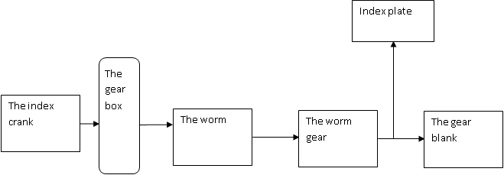

Since gear box is in the main line,
We can calculate rotation of blank as = index crank rotation X gear box ratio X worm-worm gear ratio = 1/Z amount of rotation of blank = 1/71 (say)

In other words, for the gear blank rotation, 40/71* U * 1/40 = 1/71

And for the index plate rotation (1/71) * U*1/40=(1/70) –(1/71)

Now the above equations are suggesting that there could be two values of U coming from the two. There is no guarantee that these two would be the same. So this positioning of the gear box is not acceptable.

Or perhaps

Index crank – worm ------ gear box – index plate

Worm gear ----blank
The index crank
The worm
The worm gear
The gear blank
Index plate
The gear box

Well, the gear box at least has one solution here – and what is that ?

(1/71) * U = (1/70)-(1/71)

That gives U = 1/70 but we did not implement that solution. Why ?

Or even better – throw out all these worm, worm gear, everything Just have this

U

In that case – the gear ratio should be such that you give 1/70 and out comes 1/71

Then the ratio U = 70/71

Why don’t we do that ? think about this

Reference Books :

- WAJ Chapman – Workshop Technology – Vol II
- Workshop technology – Raghuvanshi
- http://nptel.iitk.ac.in/courses/Webcourse-contents/IIT%20Kharagpur/Manuf%20Proc%20II/pdf/LM-22.pdf

