PATTERN DESIGN
Split pattern:
The pattern which goes into the drag box is:
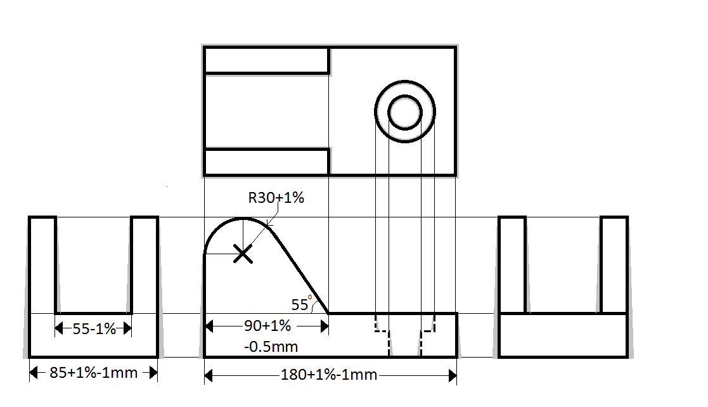
The pattern which goes into the cope box is:
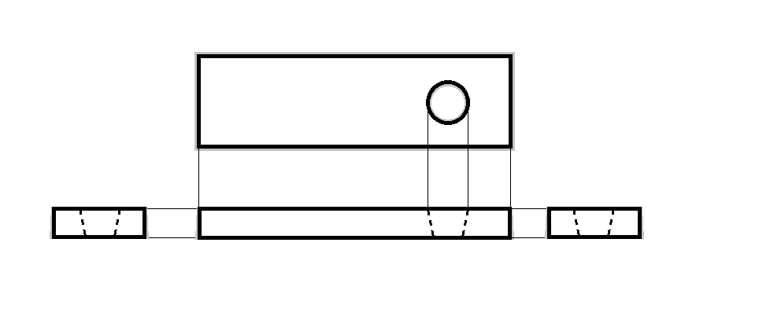
After metal has been cast, it must then be drilled.
Drill a hole with diameter of 30mm at the point X.

