SAND TESTING

Aim: To determine the changes in the properties of moulding sand by varying the clay content
by a)4% b)6% c)8% while the moisture is kept fixed at 5% of the sand weight.
Procedure:
1) Weigh 550gm of dry sand in the balance.
2) Add 22 gm/33gm/44gm of clay respectively for 4% 6% 8% of sand mixes.
3) Pour the sand and clay in a tray. Mix the sand and clay in dry condition for 1 min and then
add 28ml of water (5%) slowly. Mix for another 3 min for proper mixing
4) Prepare 3 standard sand specimens for sand mix
5) For each sand specimen measure
i) Permeability of standard and specimen
ii) Green hardness
iii) Green compressive strength
6) Plot
i) percentage clay Vs permeability
ii) percentage clay Vs green hardness
iii) percentage clay Vs green compressive strength

Procedure for Sand Specimen Preparation
In order to perform certain test the sand sample has to be moulded to standard specimen. The standard specimen is cylindrical in shape with height of 2”$±$1/16 and the diameter of 2”
Procedure
1) weigh 155 gm of clay –water mixed sand.
2) place the specimen tube holder over the base area cover and pour the weighed sand mixture into the specimen tube
3) keep the specimen tube under the standard rammer
4) drop the rammer 3 times.
5) height of the specimen tube after ramming should be such that the pointer of the rammer lies
b/w the tolerance marks

Instructions to determine the permeability number
Permeability is expressed in terms of permeability number, which is defined as a volume of air in cubic cm that will pass per min through a sand sample 1 sq cm in cross section and 1 cm high at pressure difference of 1 gm per sq cm.
Permeability is expressed in term of AFS permeability number.
AFS permeability number = (V*H)/ (P*A*T)
if
V = 2000cc of air
H = 2” the height of specimen
P = pressure in gm/cm2
A = 20.268 cm sq (Cross section of specimen)
T = Time in minutes.
- Prepare Sand Specimen
- Turn the valve so that D is positioned at window
- Lift air tank till 0 mark in air tank flushes with water tank
- Turn the valve clockwise in position O at window
- Place the SS inverted over rubber sealing boss
- Note initial reading of water column in manometer
- Turn the valve anticlockwise so that P is positioned at the window. simultaneously switch on the stop watch
- Note the final reading of manometer
- Stop the watch when the 2000 mark on the air tank flushes with water tank.
- Calculate the permeability number from the chart
- The same permeability no may be calculated from the formula given below
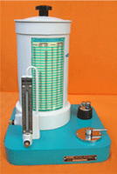

Instructions to Operate Universal Sand Strength Testing Machine
1) Place the magnetic rider on the graduated scale.
2) Make a standard AFS specimen
3) Insert the compression heads in the bottom hole of the machine.
4) Move the specimen holder by rotating hand wheel anticlockwise to prevent the specimen from crushing during accidental release of the pendulum.
5) Place the rammed specimen between the compression heads so that the face that was uppermost in the ramming operation is facing the right hand compression head of the machine. While the pendulum is released care should be taken so that the compression head does not pierce the specimen.
6) After the specimen after being properly loaded the magnetic rider is fixed adjacent to the pendulum on the graduated scale and then the pendulum is moved in the upward direction by rotating the hand wheel slowly and uniformly in clockwise direction. As the pendulum moves up the incline the magnetic rider also climbs up. It stops at a place where the specimen ruptures as the magnetic rider sticks at the place where the ram slips back. THE READING FOR GREEN COMPRESSIVE STRENGTH IS READ FROM THE SECOND SCALE FROM THE BOTTOM IN PSI.
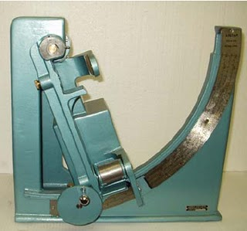

To find out the Green Hardness of the Sand Mould
OPERATION INSTRUCTIONS: Apply the instrument vertically by placing the tip on the mould surface of which hardness is to be measured as is shown in the figure.Gently press on the surface until the surface of the bottom ring contacts the mould surface throughout the periphery the depth of the penetration of the tip into mould indicates the green hardness which is indicated on the dial directly

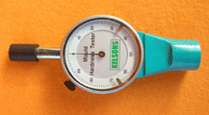

Observations:
