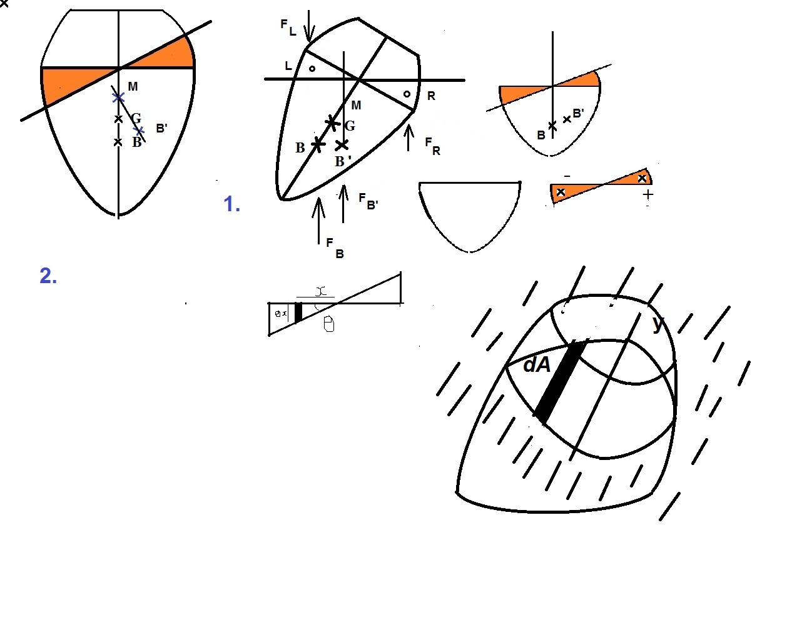
The vessel upright in Fig 2 tilts to a position in Fig 2 by angle Ɵ. The Orange sections are the addition and deduction in the submerged portion of the vessel.
G is the centre of gravity of the vessel. It remains fixed with respect to the body. B is the centre of Bouyancy, the body being symmetric it is in the centerline directly below G, when it is in equilibrium. When the vessel is tilted anticlockwise there is more volume of displaced water on the right than on the left. The Addition has its centroid at R and the subtraction at L. The new centre of buoyancy is B’, to the right of B as a result of addition and subtraction.
A vertical line through B’ cuts the centerline at G as shown. This is called the metacentre M and it is above G in this picture, though it is not so for all floating bodies.
Taking moments about the vertical axis through G to find how B has shifted to B’,
$F_{B^{'}}*BB^{'}= F_{B}*0+F_{R}*RB-F_{L}*LB$
BB’=MB*Ɵ; F_{R}*RB=$ρgƟ\int_{0}^{R}{x^{2}dA}$; F_{L}*LB=$ρgƟ\int_{0}^{-L}{x^{2}dA}$
F_{B} = F_{B’}= ρgV, where V is the volume of displaced liquid.
Hence $ρgV*MBƟ$= ρg$I_{yy}Ɵ$
Therefore $MB=I_{yy}/V$.
If B’ is to the right of G, there is a anticlockwise restoring couple, that restores equilibrium. If B’ is not so then the vessel is unstable. For this MB>GB.
For stable equilibrium; $\frac{I_{yy}}{V}-GB>0$

